10. Scenario: You are working on a data visualization project and need to create basic plots using

Matplotlib. You have a dataset containing the monthly sales data for a company, including the

month and corresponding sales values. Your task is to develop a Python program that generates line

plots and bar plots to visualize the sales data.

Question:

1. How would you develop a Python program to create a line plot of the monthly sales data?

2: How would you develop a Python program to create a bar plot of the monthly sales data?

CODE:

import pandas as pd

import matplotlib.pyplot as plt

file_path =r"C:\Users\Shashankbheemavarapu\Downloads\monthly_sales_data.csv"

sales_data = pd.read_csv(file_path)

# Extract data for plotting

months = sales_data["Month"]

sales = sales_data["Sales"]

# 1. Create a line plot of the monthly sales data

plt.figure(figsize=(10, 6))

plt.plot(months, sales, marker='o', linestyle='-', color='b', label="Sales")

plt.title("Monthly Sales Data - Line Plot")

plt.xlabel("Month")

plt.ylabel("Sales")

plt.xticks(rotation=45)

plt.grid(True)

plt.legend()

plt.tight_layout()

plt.show()

# 2. Create a bar plot of the monthly sales data

plt.figure(figsize=(10, 6))

plt.bar(months, sales, color='skyblue', label="Sales")

plt.title("Monthly Sales Data - Bar Plot")

plt.xlabel("Month")

plt.ylabel("Sales")

plt.xticks(rotation=45)

plt.grid(axis='y')

plt.legend()

plt.tight_layout()

plt.show()

**output:**

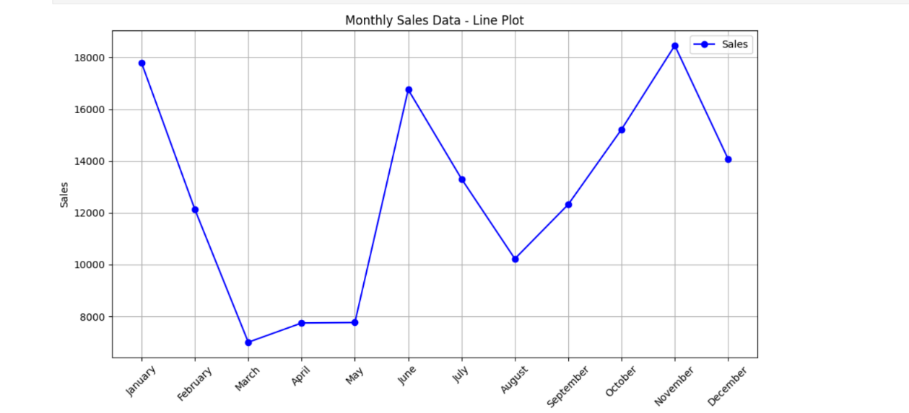

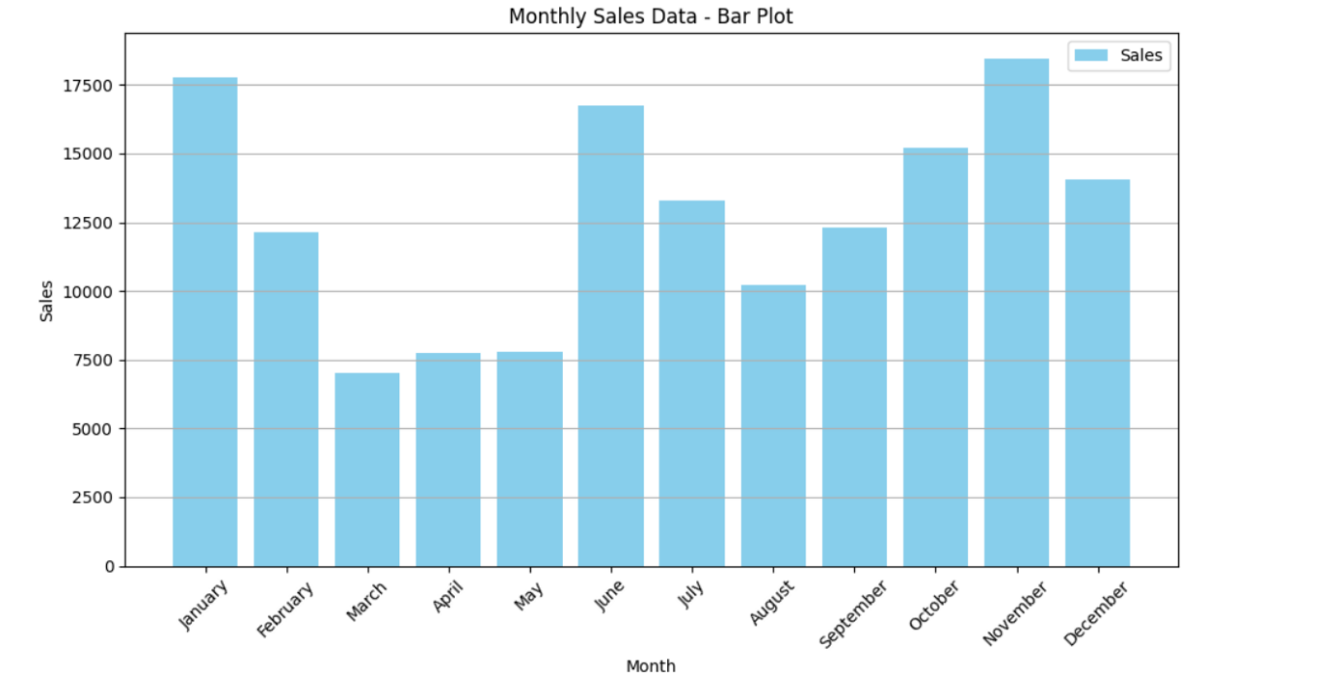

**DATASET:**

|  |  |
| --- | --- |
| Month | Sales |
| January | 17779 |
| February | 12123 |
| March | 7009 |
| April | 7750 |
| May | 7769 |
| June | 16752 |
| July | 13310 |
| August | 10228 |
| September | 12321 |
| October | 15217 |
| November | 18454 |
| December | 14078 |